
To: EC, GC, and Society Officers
From: Brent St. Denis, Treasurer
Re: Treasurer’s Report as of NOVEMBER 30th , 2025

Hi everyone – here is the latest update on Fellowship finances as of the end NOVEMBER 2025.
This report is provided to the Fellowship’s General Council and Society leadership in CONFIDENCE. Please do not share beyond your leadership circle without permission. And as always, a BIG thank-you to Geoff for keeping the good records that make these reports possible.

A QUESTION THAT COMES UP EVERY SO OFTEN – for further comments go to the very bottom of this report.

Investments – The following year-to-date summaries are excerpted from the October month-end investment reports. As of this writing on December 9th, the total value of assets held in investments is about $2,719,000 which is a little above the 2024 year end portfolio balance of apprx $2,666,800. This is after draws for operations including conferences (IC26), market uncertainty and a couple of exceptional donations.
The Legacy/Estate Donor program is an important initiative. Please consider UBF in your final estate plans. https://urantiabook.org/donations
The Fellowship’s Stewardship Committee is working to expand our donor base of both smaller and larger gifts including those able to remit smaller but important monthly amounts of $10/mo or $20/mo or more by auto-debit. Please consider signing up if you have not already done so.
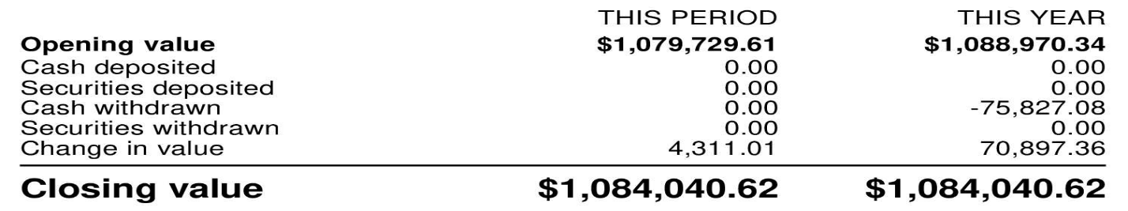
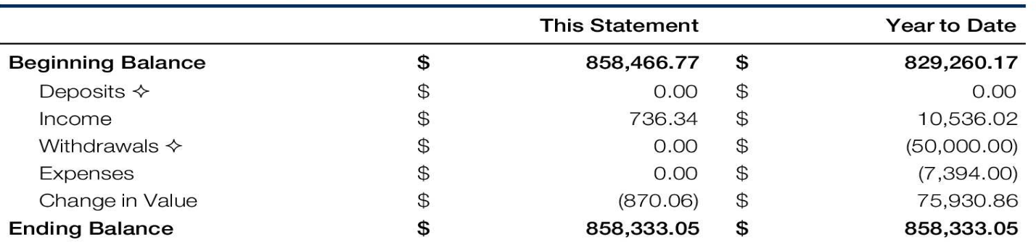
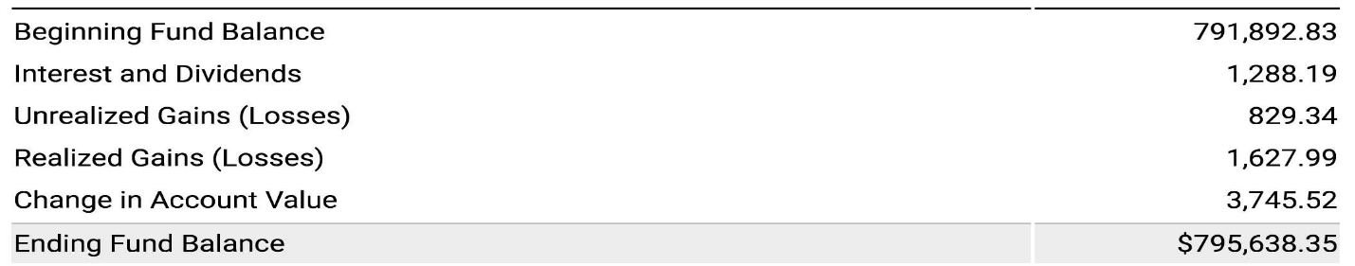
KANSAS CITY CF

IT, Standing Committees and selected other Expenditures
to end NOVEMBER, 2025 with previous year

 | Jan 1 - Nov 30 2025 | Jan 1 - Nov 30 2024

5200000 Contract Services
5231000 Spanish Reader Services | $23,905 | $4,894
5241000 IT/Web Consultants | $4,200 | $2,800

5240000 IT/Web Coordinator
5241001 IT Consultant Content | $1,412 | $9,355
5241003 IT Consultant Admin Functions | $943 | $7,183
Total for 5240000 IT/Web Coordinator | $2,355 | $16,537
5241002 Consultant - Communications | $20,269 | $16,916
Total for 5241000 IT/Web Consultants | $26,824 | $36,253
5260000 Audit Fees | $10,000 | $10,115
5250000 Accounting Fees |  | $0
5270000 Legal Fees |  | $2,088
Total for 5200000 Contract Services | $60,729 | $53,350
5231000 - Spanish Reader Services | $3,030
5241001 - Consulting Content | $1,953
5241003 - Web/IT Consultants | $3,868
5260063 - EC Special Projects | $2,635

5300000 Committee Expense

5300300 Committee-Interfaith
5300340 Interfaith - Events & Projects | $475
Total for 5300300 Committee-Interfaith | $475
5300400 Committee-Outreach | -$279
5300420 Outreach - Fairs & Expos | $9,802 | $6,616
5300430 Outreach - Programs | $73 | $565
5300460 Outreach - Books & Supplies |  | $1,459
Total for 5300400 Committee-Outreach | $9,596 | $8,640

5300500 Committee - Int'l Fell
5300541 Int'l Fell - Special Projects | $54,295 | $35,279
5300560 Int'l Fell - Outreach Materials |  | $233
Total for 5300500 Committee - Int'l Fell | $54,295 | $35,512

5300700 Committee - Publications
5300720 Publications - Postage | $97
5300730 Publictns - Fellowship Herald | $4,759
5300740 Publications - Labor | $1,985 | $2,616
5300790 Publications- Miscellaneous | $131 | $237
Total for 5300700 Committee - Publications | $6,972 | $2,853
5300800 Committee- Finance |  | $576
5300822 Finance - Shipping/Postage | $581 | $4,554
5300826 Finance - Special Project | $5,382 | $5,067
Total for 5300800 Committee- Finance | $5,963 | $10,196

5300950 Committee - YaYA
5300955 YaYA - Events | $2,402 | $1,553
5300954 YaYA - Travel |  | $1,650
Total for 5300950 Committee - YaYA | $2,402 | $3,203

5300600 Committee-Education
5300620 Education - Travel Expense |  | $3,000
Total for 5300600 Committee-Education |  | $3,000
Total for 5300000 Committee Expense | $79,703 | $63,405
5301000 - conference expenses | $1,261
5301000 Conference Expenses | $81,078 | $99,633
5360000 Special Programs |  | $210
5360029 ACFW Program - Domestic | $1,178 | $3,415
5360030 FEF SMF Grants | $4,506 | $16,976
5360032 Study Group Directory | $1,000
5360033 Womens Fund Grants | -$500 | $2,639
Total for 5360000 Special Programs | $6,184 | $23,240
5360030 · FEF SMF Grants | $23,599
5360033 - womens fund grant | $1,205
5360060 Website/IT Expense | $95
5360040 Spanish Website | $4,827
5360050 English Website | $24,369 | $19,183
5360064 Web/IT- Software/Platform Fees | $16,431 | $14,851
Total for 5360060 Website/IT Expense | $45,722 | $34,034

5360590 Pipeline of Light
5360592 POL - Shipping / misc | $312 | $352
5360596 POL - Prison Shipping | $4,996 | $3,933
5360591 POL - Books |  | $252
Total for 5360590 Pipeline of Light | $5,308 | $4,537
5361000 Programs UB Shipping | $1,728 | $2,529
5361000 - UB Shipping | $2,472

SUMMARY PROFIT AND LOSS TO NOV 30, 2025 with previous year
(aka Statement of Activity)
 | Jan - Nov, 2025 | Jan - Nov, 2024
Revenue
4000000 Contributions | 160,081 | 408,696
4100000 Sales | 15,809 | 19,669
4200100 Conference Income | 157,313 | 108,273
4300000 Interest Earned | 7,858 | 13,511
4350000 Dividends Received | 35,762 | 43,031
4400002 Gain(Loss)-Sales of Securities | 29,009 | 15,535
Total Revenue | 405,832 | 608,715
Cost of Goods Sold
5000000 Cost of Goods Sold | 25,340 | 29,050
Total Cost of Goods Sold | 25,340 | 29,050
Gross Profit | 380,492 | 579,665
Expenditures
5100000 Employee Expense | 87,803 | 85,474
5200000 Contract Services | 60,729 | 53,350
5231000 - Spanish Reader Services | 3,030
5241001 - Consulting Content | 1,953
5241003 - Web/IT Consultants | 3,868
5260063 - EC Special Projects | 2,635
5300000 Committee Expense | 79,703 | 63,405
5301000 - conference expenses | 1,261
5301000 Conference Expenses | 81,078 | 99,633
5360000 Special Programs | 6,184 | 23,240
5360030 · FEF SMF Grants | 23,599
5360033 - womens fund grant | 1,205
5360060 Website/IT Expense | 45,722 | 34,034
5360590 Pipeline of Light | 5,308 | 4,537
5361000 - UB Shipping | 2,472
5361000 Programs UB Shipping | 1,728 | 2,529
5400000 EC/GC | 13,776 | 219
5600000 Administrative Expense | 24,094 | 29,102
5800000 Depreciation and Amortization |  | 7,880
7400010 Taxes - Other Taxes&Filing Fees | 217 | 48
9999010 Bank Service Charges | 1,583 | 1,671
Uncategorized Expense | 53
Total Expenditures | 448,000 | 405,122
Net Operating Revenue | -67,508 | 174,543
Other Revenue
4999000 Unrealized gain/loss | 174,645 | 248,238
Total Other Revenue | 174,645 | 248,238
Other Expenditures
Unrealized Gain or Loss | 0 | 0
Reconciliation Discrepancies-1 | 50
Total Other Expenditures | 50 | 0
Net Other Revenue | 174,595 | 248,238
Net Revenue | 107,087 | 422,781

SUMMARY BALANCE SHEET AT NOV 30th, 2025
WITH PRIOR YEAR (aka Statement of Financial Position)
 | As of Nov 30, 2025 | As of Nov 30, 2024
ASSETS
Current Assets
Bank Accounts
1000000 Cash Accounts | 141,671 | 209,146
Total Bank Accounts | 141,671 | 209,146
Accounts Receivable
1100000 Accounts Receivable | 2,705 | 1,765
Total Accounts Receivable | 2,705 | 1,765
Other Current Assets
1200000 Inventory Asset | 23,125 | 39,585
1299000 Undeposited Funds | 1,596 | 622
1300000 Prepaid Expenses | 98,135 | 9,905
1340000 Accrued Interest | 4,440 | 3,264
5360050 - Website Content | 1,142
Total Other Current Assets | 128,438 | 53,376
Total Current Assets | 272,813 | 264,288
Other Assets
1700000 Investments | 2,726,338 | 2,719,412
1800000 Other Assets | 22,958 | 0
Total Other Assets | 2,749,296 | 2,719,412
TOTAL ASSETS | 3,022,109 | 2,983,700
LIABILITIES AND EQUITY
Liabilities
Current Liabilities
Accounts Payable
2600000 Accrued Expenses | 17,653 | 18,385
Total Accounts Payable | 17,653 | 18,385
Total Current Liabilities | 17,653 | 18,385
Total Liabilities | 17,653 | 18,385
Equity
3000000 Unrestricted net assets | 2,340,520 | 2,409,253
3200000 Temporarily Restrict Net Assets | 22,972 | 18,831
3900 Retained Earnings | 533,877 | 114,451
Net Revenue | 107,087 | 422,781
Total Equity | 3,004,456 | 2,965,315
TOTAL LIABILITIES AND EQUITY | 3,022,109 | 2,983,700

A QUESTION THAT COMES UP EVERY SO OFTEN – a question that on occasion comes from members of our community is “since it seems we have a fair amount of cash available to us why don’t we spend more to advance the revelation?” That is a fair question and the short answer is that we spend most of our income on advancing our mission but we do so mindful of the fact that until regular donations hit a sustainable level, we need the proceeds from our investments to make up the difference plus to add some extra in the piggy-bank to see us through stormy times. If we overly deplete our invested funds the returns may not cover the donation gap. The goal is to close that gap which is where all of us can help by pitching in. Contributions small and large all have an important impact.

The funds in our possession are an endowment entrusted to us. Over $200,000 per year of earnings from our savings plus 100% of regular donations annually go to support our annual. In other words about 85% of our entrusted funds are needed to generate the financial support needed for our annual mission and about 15% for our future needs. Our funds are put to work to support the work of the revelation. Closing the donation gap is very important for long-term sustainability.

BTW – the Urantia Book Fellowship has consistently maintained Platinum level top ratings for non-profit fiscal responsibility.

