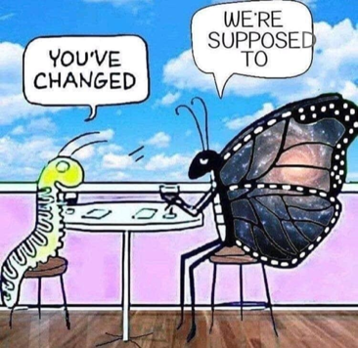

**Living Morontially:**

**From Information to Transformation to Application**

“*…mortal personality, through its own choosing possesses the power of transferring its seat of identity from the passing material-intellect system to the higher morontia-soul system which, in association with the Thought Adjuster is created as a new vehicle for personality.*”(112:2.20)

"Living Morontially" is an experiential workshop designed to explore ways to consciously apply the teachings of *The Urantia Book*.

Would you like to join others in a journey to take the inspiring words off the pages and into your life? Together we’ll share our experiences and encourage each other with a variety of strategies to discover how to reflect God’s will and way.

This two-session workshop will be held on Friday, July 22nd in both morning and afternoon sessions. **Pre-registration is required by** **June 23rd**; participants will be given a short assignment in advance of the workshop. The workshop is led by Bobbie Dreier, Sharri Gaines, and Sherry Cathcart Chavis.

To register, or for more information, send an email with your phone number to Bobbie Dreier at [bdreier@earthlink.net](mailto:bdreier@earthlink.net).