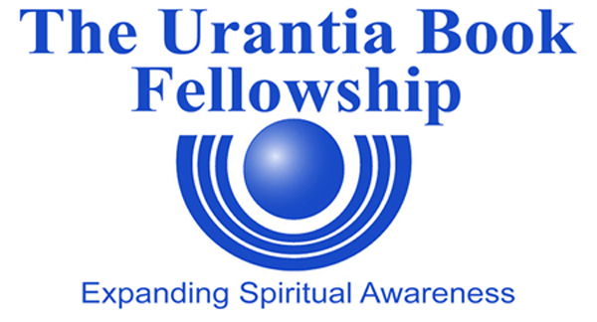

CERTIFICATION OF ELECTION OF
SOCIETY DELEGATE AND ALTERNATE DELEGATE
TRIENNIAL DELEGATE ASSEMBLY OF July 8, 2015

Within 15 days of the election of your society Delegate and Alternate Delegate, please complete and return this form as shown below.

Date: _______________________

This is to notify you that at a meeting of the

__________________________________________________________________________
(Official Name of Society)

held on (date) ___________________, we elected

__ as our Delegate
(Print Delegate name)

to the Triennial Delegate Assembly to be held on Aug 1st, 2012 and we elected

_________ as our Alternate Delegate.
(Print Alternate Delegate name)

Society Secretary_____________________________________________________________
(Please sign and print name.)

Certified by:
President_____________________________________________________________________
(Please sign and print name.)

Return by mail to:
The Urantia Book Fellowship
9190 West 90th Place
Westminster, CO 80021

Email: Fellowship@urantiabook.org

PT 5/21

