Organizational Resources for Society Officers and their members

The Membership Committee, with cooperation of the Executive Committee (EC) of The Urantia Book Fellowship have all been working diligently to make modifications to policies and procedures within the organization that will benefit societies and members alike. We are making changes in the structure of membership and the way we communicate with the societies and their officers. For over a year, the General Council has had discussions, both in person and by Zoom conferences to find better methods of communicating.

This outreach newsletter is a pilot program that attempts to make these deeper connections between you and the larger organization, and provide information and resources that will help you grow your organization which will eventually further our goals of spreading these teachings better contributions to the function of The Fellowship as a whole.

As many of you are aware, the last couple of years we moved the website to a new platform called Wild Apricot (WA). There are a lot of changes, and it may take time to get acclimated to them. Many of those changes will contribute to greater communication between members and their societies, as well as providing additional access to The Fellowship’s resources. Richard Daunt covers this in his article, and we hope you can utilize this information for your society.

This upcoming year the Triennial Delegate Assembly (TDA) elects new members of the General Council. This is also the time that societies may present resolutions intended to make improvements within the GC and for the benefit of societies. Bob Arkens has written on this subject as an aid in preparing for this upcoming summer’s election. The TDA is what makes our us a grass-roots organization, societies can select the best among them as officers in the larger assembly.

Of course we are sending this to the Officers of each society, but we hope you will share this information with your society members so they too may benefit from the changes being made.
__________________________________________________________

The Triennial Delegate Assembly
Robert Arkens


Flag image from the first TDA in 1964

I am going to share my understanding of the purpose and past practices of the Triennial Delegate Assembly.

Purpose
There are two purposes of the assembly of delegates from the societies. The first is to elect (qualified) people to the General Council. The second is to advise the General Council of the desires of the membership, through the societies.
When recruiting and voting for nominees for the General Council, please keep the idea of “qualifications” in mind. Here is an incomplete list:
- financial businesss sense or experience
- “spreading the book” experience, Christians call it evangelism
- computer skills, writing code and/or internet and web page skills
- people skills, leading collaborative teams
- the ability to accept compromise and not quit in a huff
- committee endurance, can you sit for long hours on a deliberative (not action) committee
- experience in the institutions (Societies, Associations, Fellowship, UAI, Foundation)
- languages

The second purpose is to advise the General Council as to the desires of the membership. This is done through the resolutions it passes, or not. Keep in mind that such resolutions are advise, not mandates. The process involves;
- a society seeing a problem or having a desire
- the society passes a resolution and sends it to the TDA with its delegate
- the TDA considers it and and votes it up (it gets sent to the General Council) or down (it dies)

Resolution Anatomy
Resolutions start with stating a problem and end with a solution. For example:

Whereas we know driving takes up a lot of your time, and
Whereas we know you don’t like loud music, and
Whereas you’re older and your reflexes are getting slower, and
Whereas Bobbie is now sixteen and has her driver’s license, and
Whereas Bobbie needs to have more driving experience before she starts driving with friends in the car,
Therefore, be it resolved that you should let Bobbie drive us to the Country Music Fest this weekend.

We use “Whereas” for highlighting the problem(s) and “Therefore, be it resolved” is used for presenting the solution.
When writing them, include all the reasons, outline the problem as thoroughly as you can. Build your biggest and strongest case. Don’t presume your delegates will present a good case verbally at the TDA. Don’t presume other societies’ delegates will intuit the wisdom of your proposal. Put in all the “Whereas’s” you can think of.

TDA Past Practices
The TDA will be called to order by the Fellowship President. The first order of business will be to elect a chair, at which point the President leaves. Sometimes the TDA wants two chairs, one for the elections and one for the resolutions. Sometimes it wants one for the whole shebang.
There will be some questions practices to consider.
- Will the Society send both its delegate and alternate? (Both are welcome and encouraged to attend.)
- Are visitors allowed? (often for the resolutions, never for the elections)
- Are delegate alternates allowed to speak? (In my experience, always yes.)
- For elections, the need for confidentiality is reviewed. In the process of reviewing candidates, personal information will be handled with utmost discretion.

A Committee of the Whole
Officially, a TDA nominating committee selects only those candidates for election to the General Council that it deems worthy, and passes those names onto the entire Assembly of delegates. In past practice, the “nominating committee” is the whole TDA, a Committee of the Whole. The entire Assembly listens to each candidate’s qualifications and proceeds to vote. Each society gets one vote.
That slate of accepted nominees is then “sent” to the Assembly and the Fellowship President is invited back in to conduct the official vote of candidates.
While appearing cumbersome, this process allows everyone in the Assembly to hear the merits and shortcomings of each candidate.

Resolutions
Resolutions start with the societies. To the best of their ability they will please publish them to SocAdmin well before the TDA convenes.
Expect to have healthy discussion of and amendments proposed to the resolutions. Be emotionally prepared to have your resolution voted down. It happens. Sometimes resolutions that were beyond repair have been carefully rewritten, keeping in mind the delegates’ objections, during a short recess of the TDA and presented as a new resolution, then passed.
When the resolution portion is finished they are presented to the Fellowship President. The General Council is free to do with them as they choose. In the recent past, presidents have reported back to the societies as to the status of the resolutions they sent to the GC.

__________________________________________________________

Help Wanted: Grassroots Guidance for Our Future
Barbara Newsom

Fellowship Societies have been the foundation of our organization since the beginning. Societies have held steadfast through the ups and down of the past, faithfully electing qualified general councilors. With thoughtful deliberation, Societies presented TDA resolutions that set the course for central Fellowship services as the Urantia revelation root around the world.
As we look now to the future of a growing global community, guidance from our Societies is more valuable than ever. Facing various courses of action and many decisions, the central Fellowship officers, councilors, and committees need your Society’ experience and wisdom as we prepare for the 2021 TDA.
What are the leadership needs of the Fellowship from your perspective in local communities? Who are the best candidates you know for the next group of 12 or more leaders to serve on the General Council? Remember, members-at-large may apply to be General Councilors as well as Society members. Now is the time to reach out to and encourage dedicated volunteers to apply.
What are the principal issues that the Fellowship faces in a world of tumultuous change and expansive opportunity for spiritual transformation? What are the priorities for the Fellowship? What changes can we make to better serve the Urantia revelation? Now is the time to start drafting your resolutions.
The Membership Committee stands ready to help you prepare for the TDA. Our new Society Liaison Team was created in the fall of 2019 to support Societies, improve relationships among all members, and foster strong connections from local to central functions of the Fellowship. Consisting of Barbara Newsom, Chair, Ted Blaney, and Cecelia Lampley, the Society Liaison Team is ready to help everyone prepare for an outstanding TDA. See you (virtually) in July!

__________________________________________________________


This last year, dealing with the SARS-CoV-2 virus, many businesses, non-profits, and even families have been challenged by the restrictions on travel. But there is a way to keep in touch with each other when face to face meetings are unavailable. Zoom is a great way to keep in touch with society members, family members and others that are too far away to travel, or when face to face meetings are unlikely due to issues with Covid-19. In an effort to assist those who are unfamiliar with the process, we have enclosed instructions below:
How to Zoom
If you’re just joining a Zoom meeting, you don’t need to have Zoom installed on your computer. However, if you’re the host, you’ll need to download and install the software package. To do so, go to the Zoom Download Center and select the “Download” button under “Zoom Client for Meetings.” Instructions from the Zoom site are below:
Signing In
- Go to http://zoom.us and click on Sign In.
- You can use the "e-mail" and "password" that you have created, or use your Google (Gmail or Google App) or Facebook account to sign in with.
Note: If you do not have a current Zoom account, please click on Sign Up Free to create a new one.
Hosting a Meeting
If you do NOT have the Zoom app installed, go to zoom.us and select "Host a Meeting" to start the installation. If you DO have the App installed, see below -
- Open your Zoom app on your desktop and click Sign In.

- Log in using the E-mail and password that you have created, or with Google(Gmail), Facebook, or Login with SSO.
- Click the downward arrow and select Start with video, then click New Meeting to start an instant meeting.
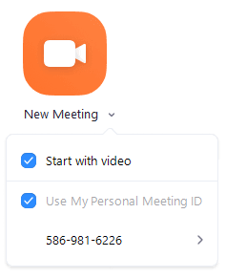

Joining a meeting by phone

Overview
You can join a Zoom meeting by means of teleconferencing/audio conferencing (using a traditional phone). This is useful when:
- you do not have a microphone or speaker on your PC/Mac,
- you do not have a smartphone (iOS or Android) while on the road, or
- you cannot connect to a network for video and VoIP (computer audio)
Zoom has toll numbers available for many countries that are included with all plans. For audio plan subscribers, Zoom also has toll-free and additional toll numbers available. The dial-in numbers available are dependent on the host's audio subscription and settings.
If the meeting invite does not provide a local number for your country, there is a more extensive list of Zoom International Dial-in Numbers. If a number is not listed or has asterisks (***) in place of some of the numbers, it means that number is not available on the account that you're currently logged into.
If you have a Zoom Phone license, you can dial in to a meeting using Zoom Phone without incurring usage charges.
Follow the sections on https://support.zoom.us/hc/en-us/articles/201362663-Joining-a-Meeting-by-Phone if you want to join a meeting using your phone.
You can also watch a video that explains the process at: youtube.com/watch?v=fGbpwZNW301

__________________________________________________________



Wild Apricot Resources for Societies
Richard Daunt

A couple of years ago we started moving our web site from Business Catalyst because it will no longer be serviced by Adobe, and we have migrated our internet assets to Wild Apricot. The WA platform has the potential to relieve Societies of the cost and administrative burden of maintaining their own website, by providing a set of pages on the Fellowship website (urantiabook.org). These pages are integrated with the membership database. This means that Societies can more easily fulfil their census requirements in a way that is visible to the Fellowship administrative staff. Society web pages can also display a society directory for ease of communication between members.
To get started, nominate your most technologically savvy society member and send an email to richard.daunt@urantiabook.org.

Public Society Pages
Each society already has a public page that can be accessed via the following menu:
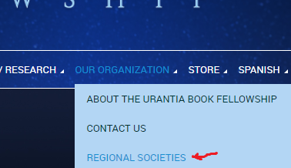
At the time of writing, the Florida Society has done the most to develop their web pages. To see an example of some of what’s possible, take a look via the following link:
https://urantiabook.org/Florida-Society

Note that your public page provides a way for curious seekers in your local area to send a message to your society without exposing any of your email addresses to web crawlers that promulgate spam. The WA system has a message form that will send you an email, at which point you can choose whether to respond (and share your email address) or not.

Here’s an example of what the messaging link looks like, from the Grand Canyon Urantia Book Society page:
Visit the page here:
https://urantiabook.org/Arizona-Society

Private Pages
Your private pages are protected by the WA authentication system. To access them, your society members must sign into the WA system on the Fellowship website. Each society member should already have an account that belongs to the appropriate security group, but if you need assistance please contact it@urantiabook.org.

Discussion Forums
Your discussion forum can be public or private; it is your choice. In any case, you can use it to post topics and have a discussion about society business and/or post meeting minutes. Here’s an example of what it can look like:
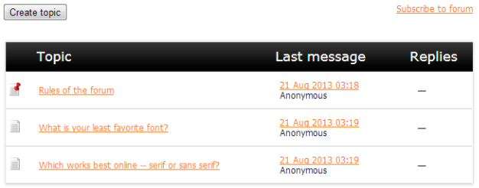

Member Directory and Map Tools
The WA member directory and map tools can be a convenient way to facilitate communication between your members, and keep track of officer positions. It can be as public or private as you choose, and each member can configure their own level of privacy. For an example of what these tools look like, please visit the “How to Connect” page on the Fellowship website:
https://urantiabook.org/How-To-Connect

Keep in mind that the default privacy level on Fellowship member accounts does not expose any personally identifiable information - only first names and zip codes. However, individuals can choose to loosen these restrictions on their information.

Configuring Individual Accounts
For most of this to work, each individual needs to take responsibility for keeping their Fellowship WA account up to date. It’s easy to do - simply log in and edit your profile:
https://urantiabook.org/Sys/Profile

Ensure your Society information is correct
If everyone’s society information is correct, the Fellowship office can easily run a report to fulfill census requirements.
Here’s what the relevant section of your profile looks like in edit mode:

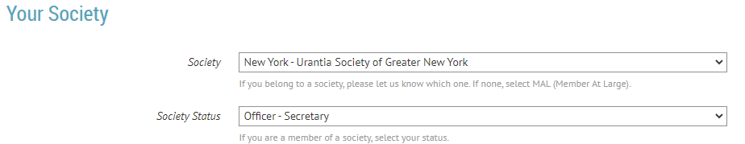

Configure your Privacy
While you’re updating your profile information, take a few minutes to configure your privacy to your liking. Click the “privacy” link to see the settings. Here’s an example:

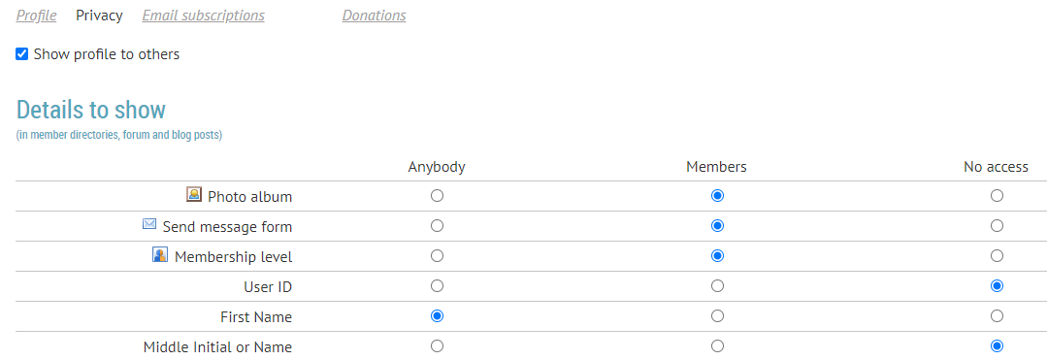
Most of these settings are related to information about you, but the “Send message form” setting determines who can send you a message via the website. Keep in mind that if you choose “anybody” for this setting, your email address will not be exposed to the public.

The Membership Committee hopes the information provided in this newsletter is helpful. If you have questions regarding these resources, you may reach out to The Fellowship office, the Membership Committee, or in the case of Wild Apricot, Richard Daunt. We are open to suggestions for the next newsletter, to be mailed in Spring 2021.

Daniel Amyx
Membership Chair
dan.amyx@urantiabook.org

